### **LEVEL DESIGN DOCUMENT**

### **Title: Dagon’s Harbor**

**Version:**

**Date : 10/02/19**

**Produced by: Julian Kelly & Kieran Lewis**

# STEP 1: IDEA

**Idea:**Dagon’s Harbor is a first-person horror game where the player is completely helpless in a desolate fishing village in the Mediterranean. Our character Matthew Blake has arrived in a village he has never seen before and has to escape from the village.

The player will have to explore and find items in order to reach the other areas of the game, some puzzles per se will have to be completed in order for the player to escape all whilst enemies that cannot be killed are roaming around. The reason for this is that Matthew isn’t just fighting a random horror villain, he is trying to escape the Dagon’s army and Dagon is a god which could easily destroy a human like our main character is.

The environment will tell the story of this desolate fishing village as no notes have been left from any previous occupants, if there were any.

**Software:**

The software we will be using for development of the game will be Unity 2018.3.2f1, this is because the two of us have used Unity a lot in the past and we are more comfortable with using it rather than Unreal Engine. We will also be staying on that version of Unity throughout development so that there aren’t any issues when opening up the project on each other’s PCs.

For development of any assets we need for the game we will be using Autodesk Maya student edition due to being able to use this for free and having learned a lot of it in a previous class at UWS.

Our project plan will be created using Microsoft Project due to it being good in the past for the creation of project plans. Any other documents will be typed using Microsoft Word

**Description:**

# STEP 2: SETTINGS, THEME AND LOCATION

# Environment Setting:

# Dagon’s Harbor takes place in a fishing village in the Mediterranean. The village is somewhere on the Mediterranean coast.

# The environment will be desolate and eerie looking with fish barrels and general clutter blocking the nearby roads and with fog emerging from the ocean. In this village there will be nearby houses along with a church that is in the town and an inn that has no occupants. The entire village has no inhabitants as if time has been frozen in place.

# The atmosphere will become drearier when the player is exiting the inn as the sun will have set and there will be fog present.

# Key Location/s:

The level will have three key locations, this first is the Inn that the player must get to when they arrive and the second is the temple/church, the third being the harbor/beach. The temple/church is the largest building in the fishing village and the one that may hold the most answers.

Within the Inn, the player will find a key to the Church allowing them to then get into it.

The harbor/beach is the final area that the player must get to as it is where the items they found previously will be used for escaping.

**Theme:**

The theme of Dagon’s Harbor is despair and dread. This is due to the harbor lacking life and there being no hope for the main character in this harbor due to the impending doom that is spiraling around the harbor.

# STEP 3: PROJECT PURPOSE

# I/We Want to Create:

A horror level where the player is helpless against a god and their antics. The player cannot obtain weapons as they would be useless due to the Dagon’s army of monsters being too dangerous to even try and fight. We want a game where the player has to explore and complete some small puzzles in order to proceed through each area of the game, we also want the player to understand just how desolate and dangerous this village is instead of seeing it as a nice Mediterranean getaway.

**I/We Want the Player to Experience the Following:**

Existential dread, sorrow and horror as they explore the eerie village. By this we mean that the player will begin to understand what is happening in the village and why the character is there in the first place and what has taken place. Through this is where the player will experience the sorrow of the village. The horror is in the village being desolate all whilst mysterious shadow figures emerge from the ocean as the fog engulfs the town.

The player will experience helplessness as they cannot fight back against anything and can only keep moving in order to escape from this horror. With the idea of the player not being able to fight back this allows them to soak up the experience of the village by looking around at everything whilst they walk about exploring and finding out where they need to be and what they need to do.

# STEP 4: FEATURES

# Features List:

* An inventory of the items the player has on them
* Scene0 - A Main Menu which will allow the player to choose to start a new game, continue their old one, view help for the game or exit the game.
* Scene1 – The main playable level situated in a Mediterranean fishing village (lit as if by late afternoon sunshine) with a limited number of unblocked routes through the streets from bus top to boarding house/inn.
* Scene2 – The same level geometry lit as if at dusk with a limited number of unblocked routes through the streets from boarding house/inn to temple/church.
* Scene3 – The same level geometry lit as if by a moonlit night with a limited number of unblocked routes from temple/church to the harbor/beach at low tide. The beach contains ancient stonework and a portal to end the level.

# STEP 5: USEABILITY AND GAMEPLAY REFERENCE AND RESEARCH

**Sources of information/inspiration**

* Provide references in accordance with University guidelines

# STEP 6: PHOTO/VIDEO REFERENCE AND RESEARCH

**Photo Reference:**

* Architecture reference

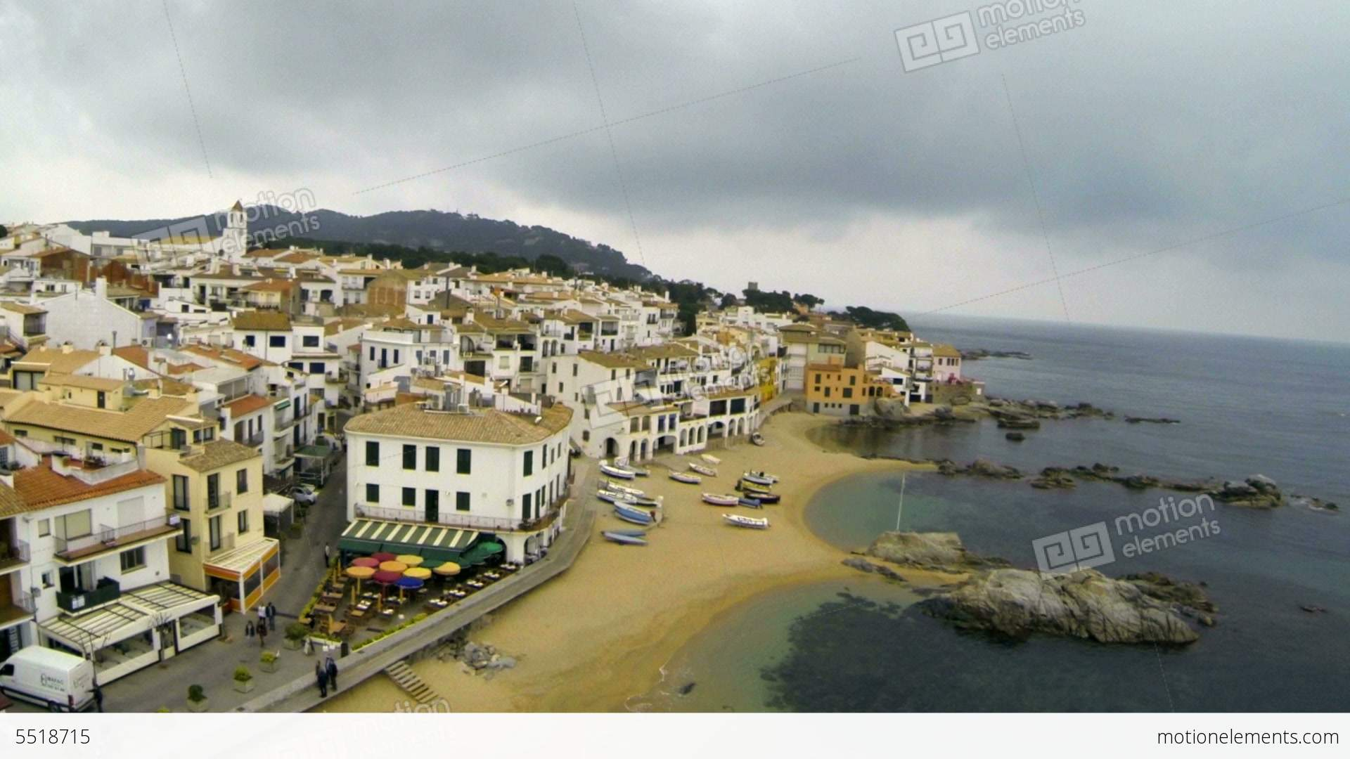

Figure 1 - Courtesy of https://www.motionelements.com/stock-video-5518715-aerial-drone-view-mediterranean-fishing-village

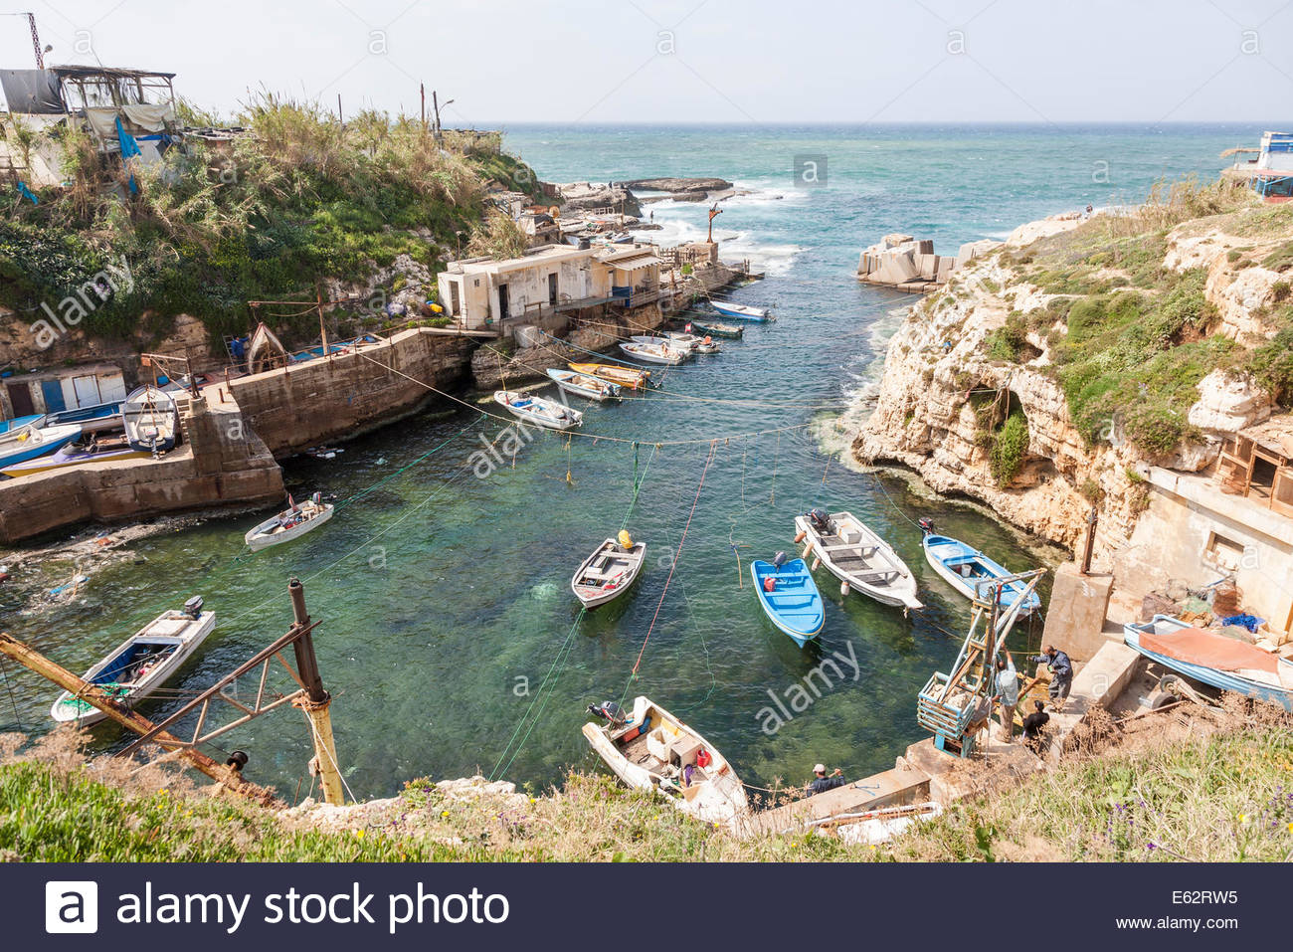

Figure 2 - Courtesy of https://www.alamy.com/stock-photo-a-small-fishing-village-community-and-harbour-on-the-mediterranean-72592049.html

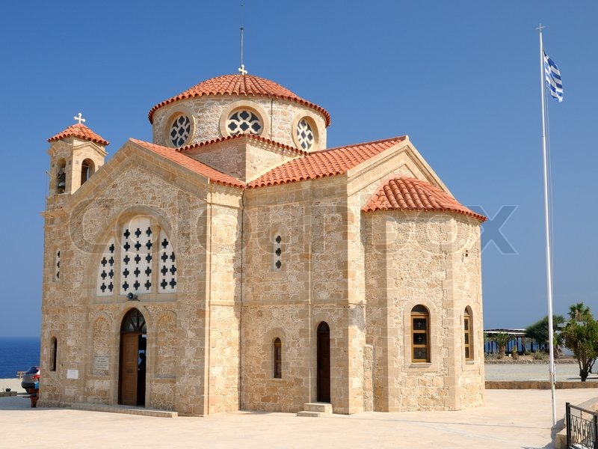

Figure 3 - Courtesy of https://www.colourbox.com/image/church-of-st-george-on-mediterranean-sea-coast-near-of-paphos-republic-of-cyprus-image-4597046

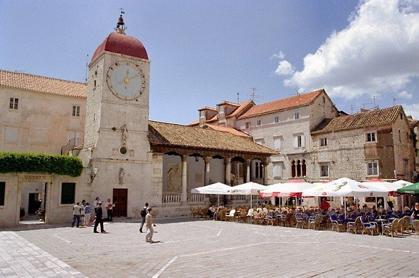

Figure 4 - Courtesy of http://www.taxi-zadar.biz/transfers/touristic-trours-and-excursions/

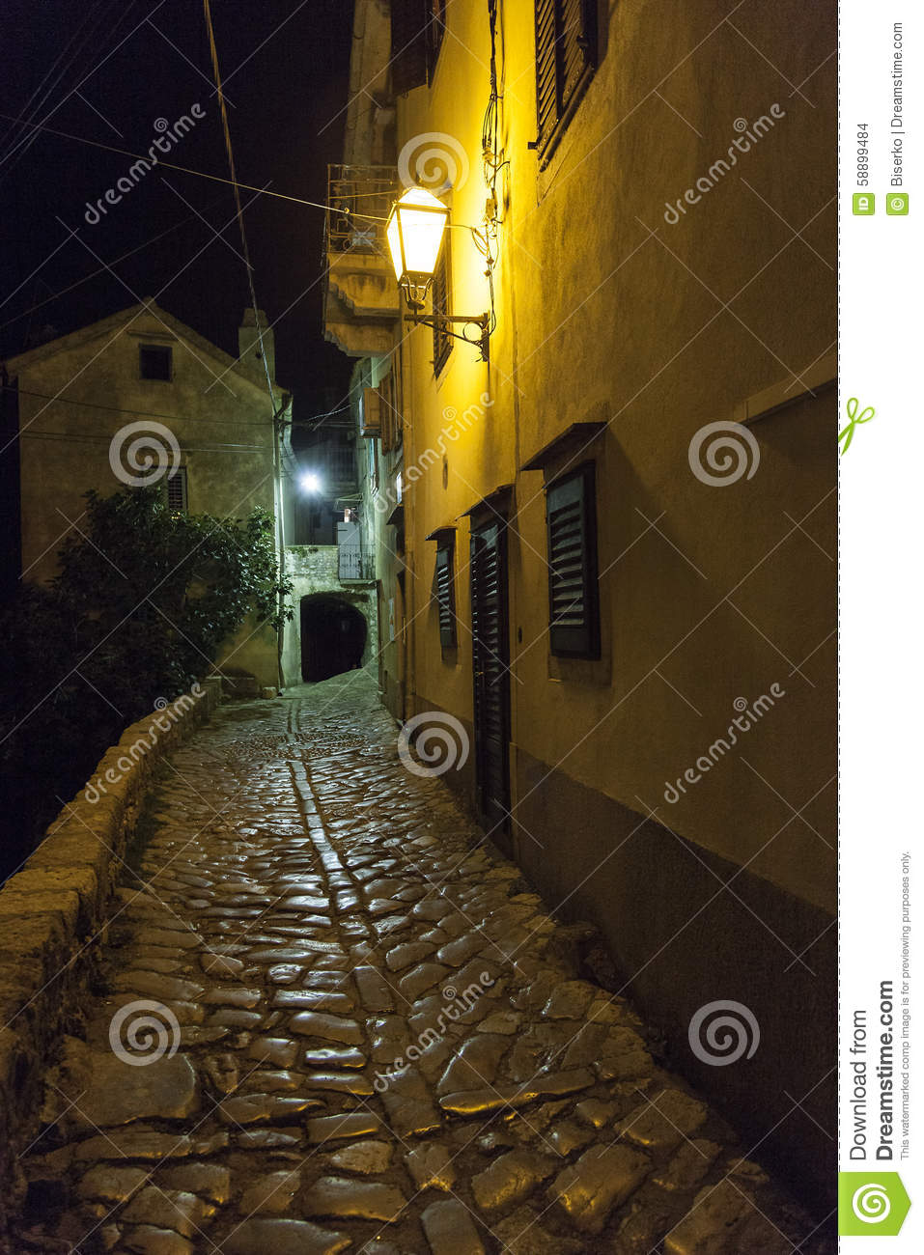

Figure 5 - Courtesy of https://www.dreamstime.com/stock-photo-ancient-street-small-mediterranean-village-traditional-stones-flooring-image58899484

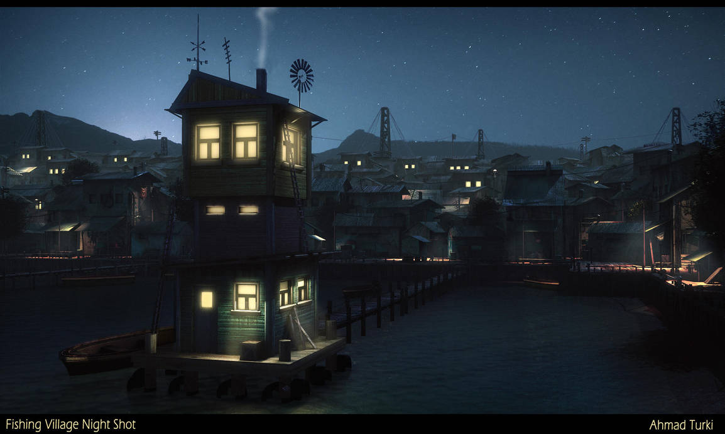

Figure 6 - Courtesy of https://www.deviantart.com/ahmadturk/art/Fishing-Village-Night-Shot-397381355

* Environment reference
* Light reference
* Prop reference

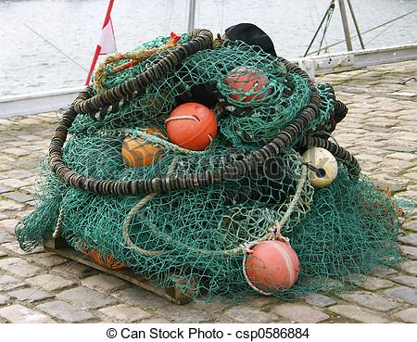

Figure 7 - Courtesy of https://www.canstockphoto.co.uk/harbour-6-0586884.html

* Inspiration reference

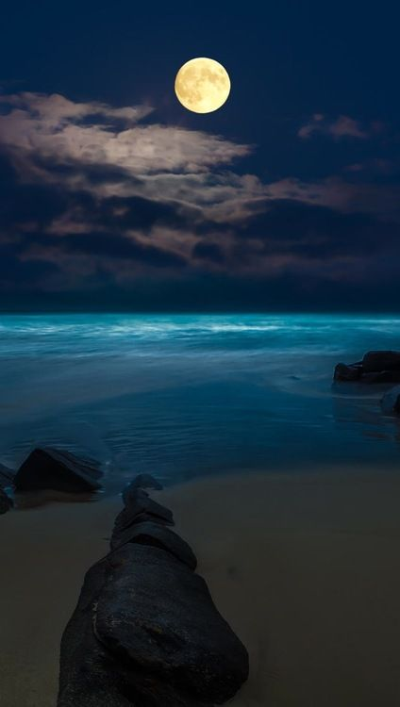

Figure 8 - Courtesy of https://www.pinterest.co.uk/pin/195906652515030147/

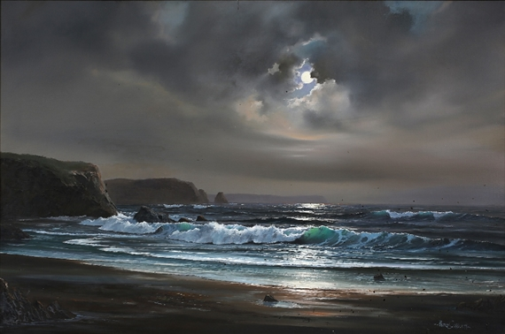

Figure 9 - Courtesy of https://www.mutualart.com/Artwork/Moonlit-beach-scene/EA82D48731898F43

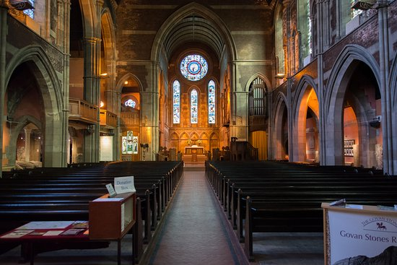

Figure 10 - Courtesy of https://www.tripadvisor.com/LocationPhotoDirectLink-g186534-d214125-i310096169-Govan_Old_Parish_Church-Glasgow_Scotland.html

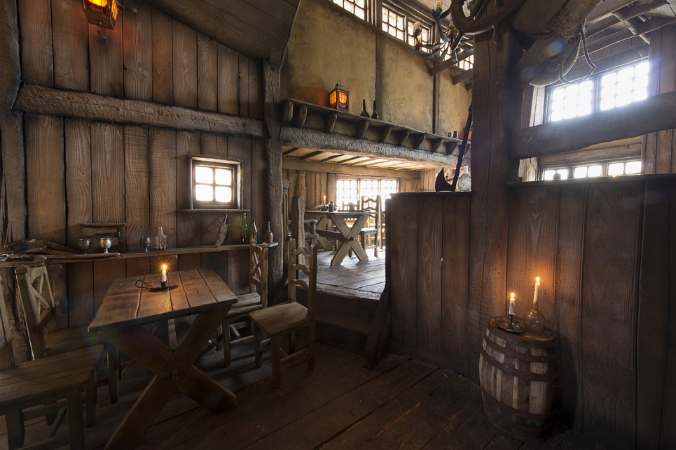

Figure 11 - Courtesy of https://homedesignersuite.co/top-3d-home-designer-for-your-perfect-home-design-project/

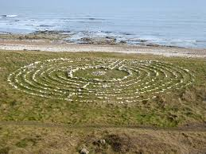

Figure 12 - Courtesy of https://www.geograph.org.uk/photo/4847636

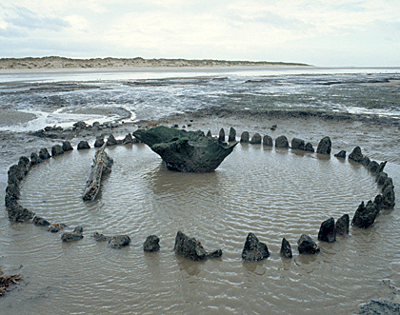

Figure 13 - Courtesy of https://www.culture24.org.uk/history-and-heritage/archaeology/art489043-Archaeologists-ring-date-ritual-Bronze-Age-stone-circle-same-year-Norfolk-Seahenge-same-year-sister-site

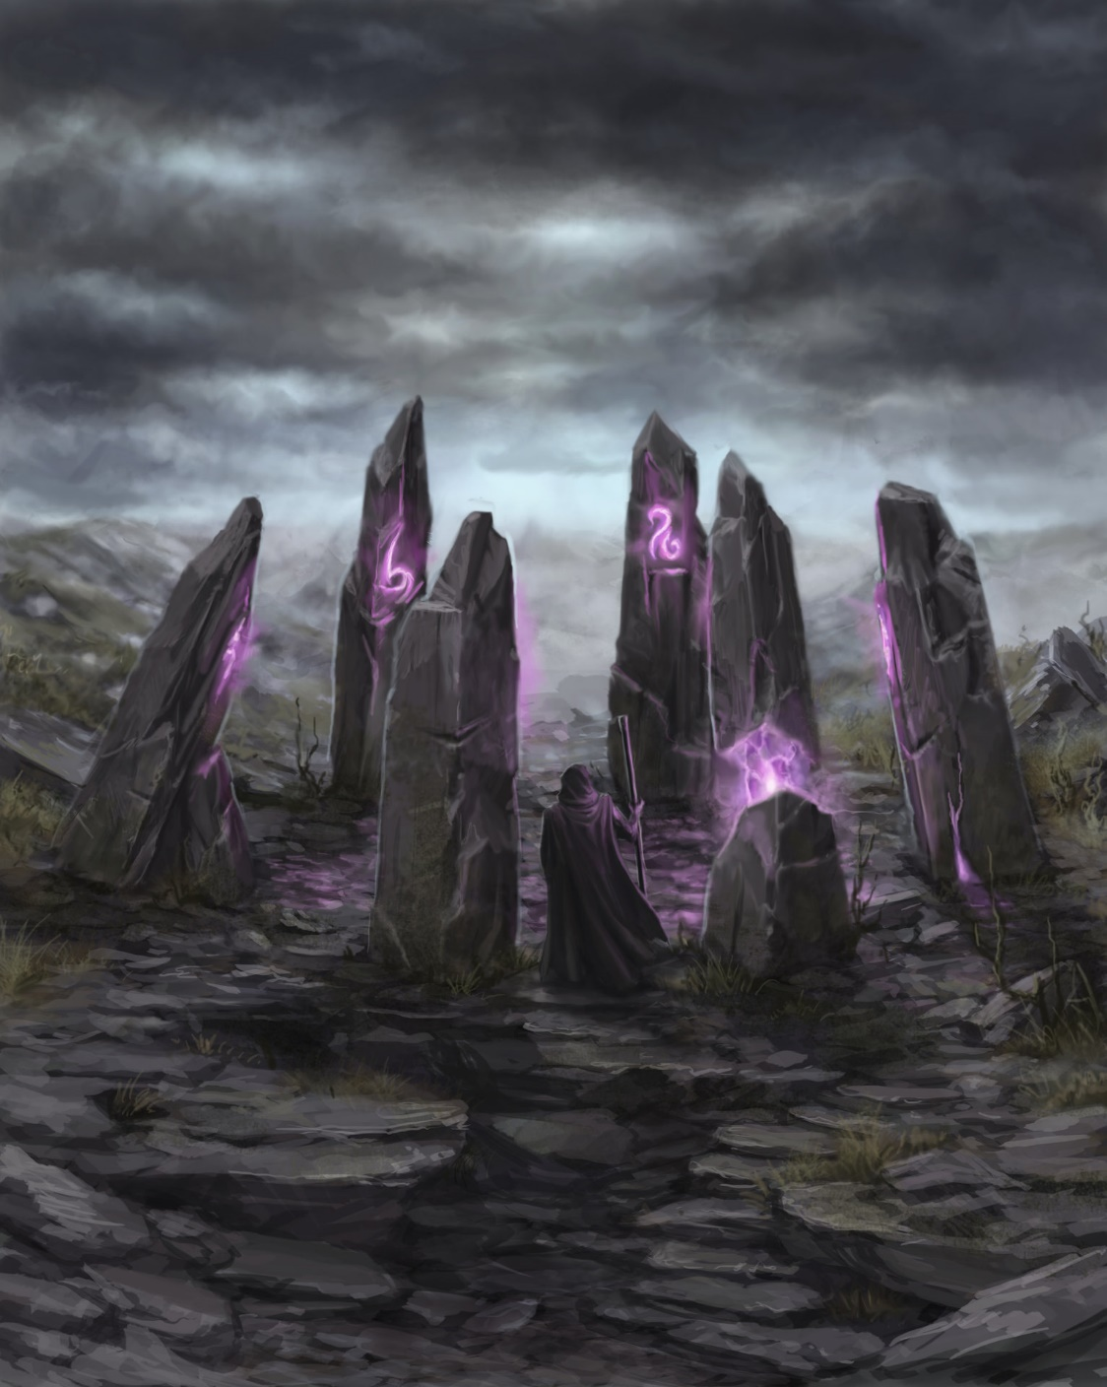

Figure 14 - Courtesy of https://sventhor.artstation.com/projects/Pe4WL?album_id=11727

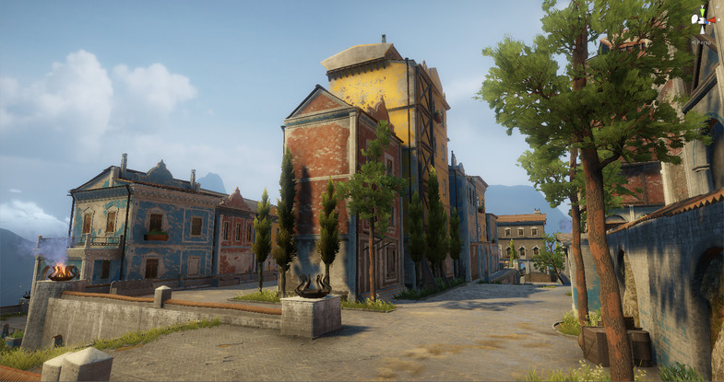

Figure 15 - Courtesy of https://assetstore.unity.com/packages/3d/environments/sun-temple-115417

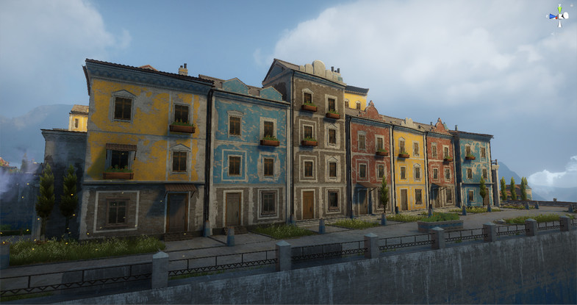

Figure 16 - Courtesy of https://assetstore.unity.com/packages/3d/environments/sun-temple-115417

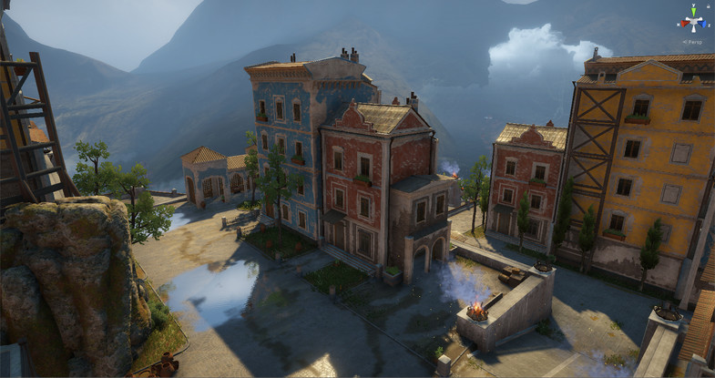

Figure 17Courtesy of https://assetstore.unity.com/packages/3d/environments/sun-temple-115417



Figure 18 - Courtesy of https://www.imdb.com/title/tt0264508/

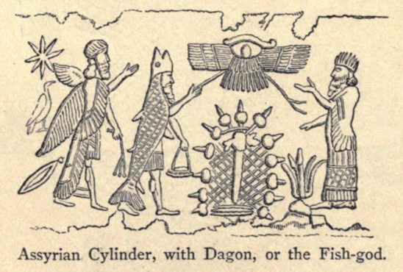

Figure 19 - Courtesy of https://mythcreants.com/blog/lessons-from-the-vivid-writing-of-lovecrafts-dagon/

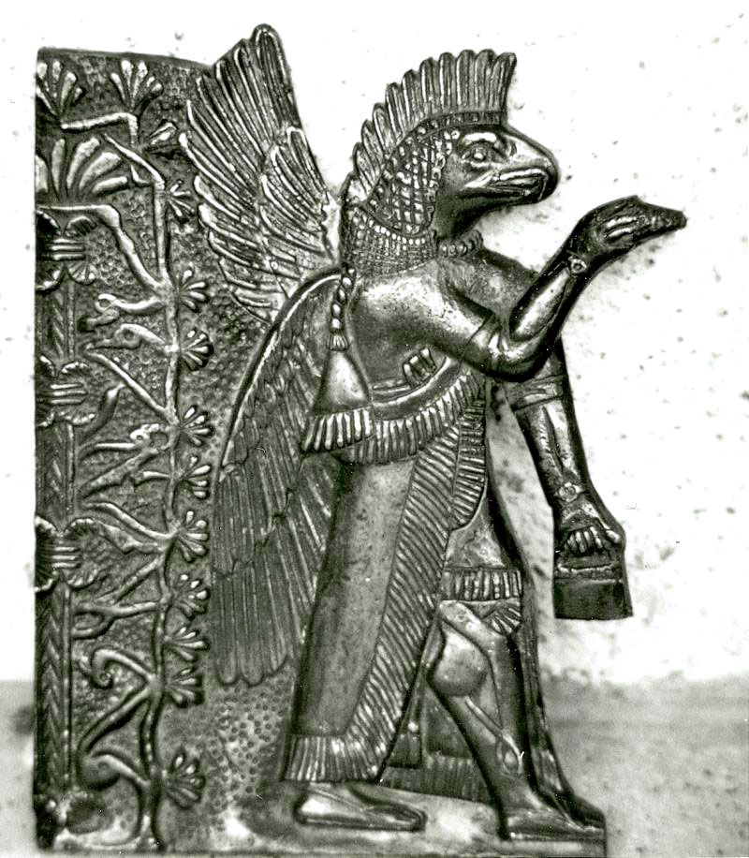

Figure 20 - Courtesy of https://www.pinterest.co.uk/pin/467318898804419661/

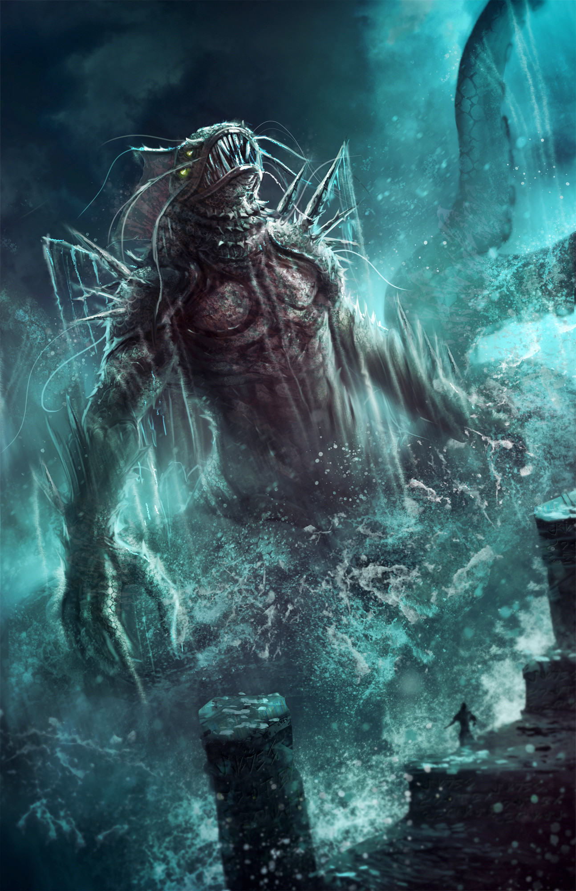

Figure 21 - Courtesy of https://www.artstation.com/artwork/JRNlz

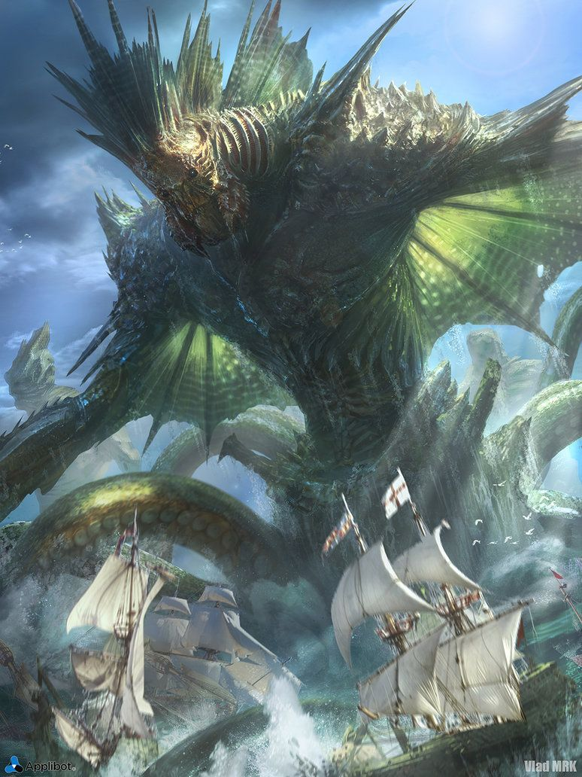

Figure 22 - Courtesy of <https://www.pinterest.co.uk/pin/412431278353989906/>

**Research:**

**STEP 7: STORY**

Story:

The story of Dagon’s Harbor is that it is a fishing village in the Mediterranean that seems to be lost in time. The village is empty due to the Dagon and his army that surrounds it.

Our main character Matthew Blake has arrived in a fishing village for a holiday but upon arrival he begins to see that there is no one around the village.

How?  
How did the player arrive in the environment? What were the events that brought them here?

Upon spawn the screen brightens from black to a Mediterranean fishing village scene. The player has arrived in Dagon’s Harbor by bus. This is intimated not shown via use of an appropriate vehicle engine sound effect and by spawning with a bus stop in the players’ view.

Why?

Why is the character here? What purpose or what goal are they to achieve?

The player is seemingly here on holiday/to visit.

# What?

What happened to the environment prior to the player arriving here?

# Show, Don't Tell

How will you show what happened to the environment? How will you tell the story of the environment to the player?

The player will see that there is a lot of damage to the village, this will be shown with barrels and other objects lying over paths that the player cannot explore. There will be houses that are destroyed showing that something was here before the player and probably will still be after or if the player escapes.

The player will know the environment has no life in it anymore due to no life being able to be found. However we will know that something is damaging the environment when the player sees the shadowy figures moving around in scene 2 of the game.

# STEP 8: SET PIECES

# (Objectives 🡪 Obstacles 🡪 Set Pieces/Scripted Events)

# Level Design / Stand Alone Game Environment:

What do you want to showcase? What do you want the player, viewer and/or designer to experience?

**Set Pieces:**

Define a set of set pieces (scripted events) that will add interactivity, atmosphere and believability to the environment.

Set piece one – player transition from boarding house/inn to temple/church – significantly different lighting and the addition of light fog.

Set piece two – Dark silhouetted figures appear in the now heavier fog. Outside the church/temple they move silently towards the beach/harbor.

Set piece three – Entry into the beach portal triggers a camera flyby of the village from bus stop to portal, achieved via Cinemachine middleware.

# STEP 9: FOCAL POINT

##### Focal Point/s:

**Uniqueness and Originality:**

* What would make your environment stand out?
* How will the player remember the environment?
* What would make your location interesting? Aesthetically, visually and architecturally?

# STEP 10: VISUAL DEVELOPMENT

**Style Reference:**

**Colour Palette:**

##### Environment Colours:

**Lighting:**

Lighting throughout the levels will be quite different. The overall sky will be dulling but still bright as the sunset is happening when the player is making their way to the Inn. After this, the sky will be darkened and some light from the moon will glare down upon the village. There will be candles that burn in the main areas that the player can explore for example, the church and the Inn.

Once the player goes to the church the sky will darken once again and the moon will be much brighter in the sky. This will illuminate the environment even further.

The player will also be able to use their flashlight in order to light up anywhere they need to see.

# STEP 11: TOP DOWN LAYOUT

Level Environment:

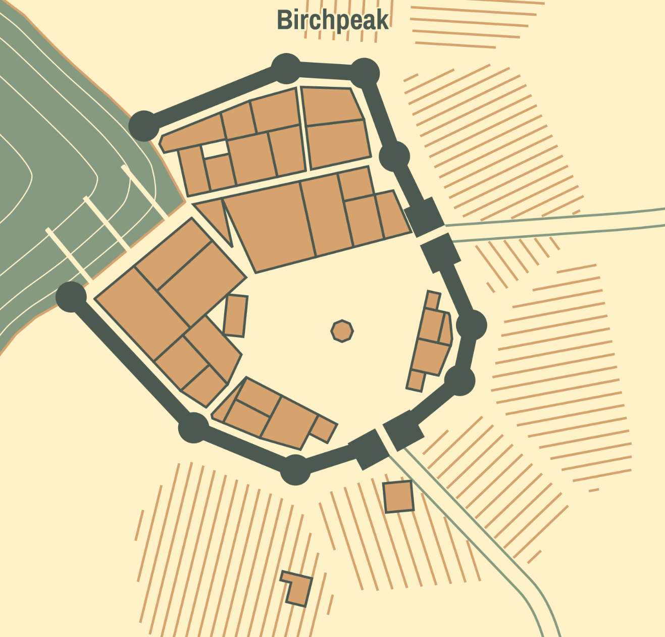

Figure 23 - Procedurally generated fishing village produced with the medieval fantasy city generator (https://watabou.itch.io/medieval-fantasy-city-generator)

# STEP 12: PROJECT PLANNING

**Project plan (Gantt) chart:**

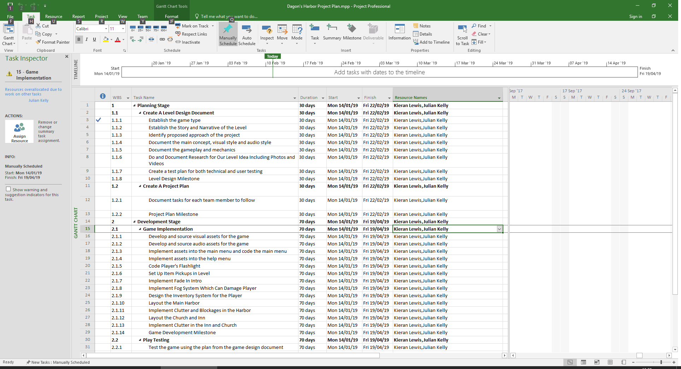

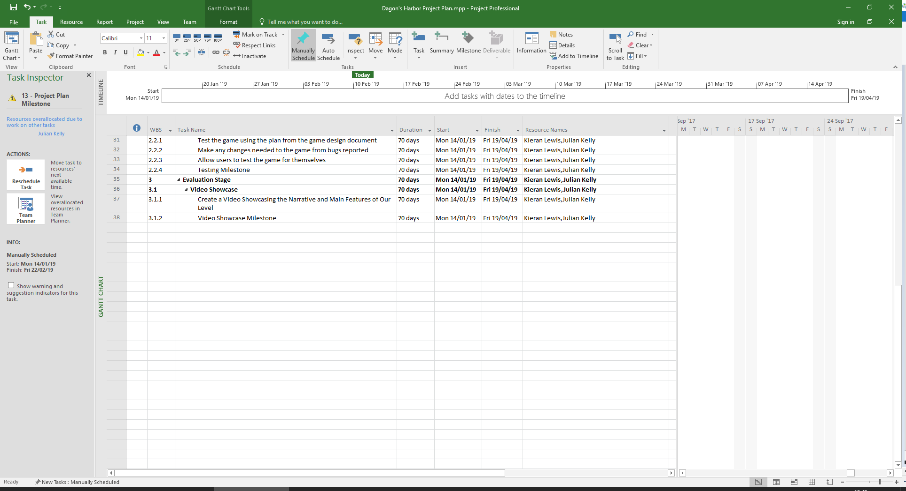

Production List:

**Props/Assets List:**

Procedurally generated terrain mesh sculpted and textured using Terrain Toolkit 2017 middleware available from <https://assetstore.unity.com/packages/tools/terrain/terrain-toolkit-2017-83490>

**Texture List:**

# Texture/Material Quality List:

# Audio List:

# STEP 13: PLAYTESTING STRATEGY

For playtesting of the game, we want a lot of people to try out the final levels. We are going to create a small questionnaire which will ask the player how they felt about the environment, the lack of combat and how difficult they found the game.

This will be a few questions on a questionnaire sheet that people can access when they play the game.

There will be some questions that ask some things on a scale of 1 – 10 but then there will be a couple of questions that will ask for a small amount of words on certain areas of the game. One of these questions will be “what is your opinion on the lack of combat” another will be “how did you feel when exploring the environment”

Getting the full opinion on each player understanding how they react to our levels will be the most important parts of the playtesting for us as it will show if our levels are really gripping and allow a good story to be told through playing rather than reading or listening to books or people speaking.

# References

**There are no sources in the current document.**